2015 Endocrine and the Autonomic Nervous System Topic Test

Name_________________________________________________

|  |  |  |
| --- | --- | --- |
| Section | Possible mark | Your mark |
| 1 | 10 |  |
| 2 | 45 |  |
| Total | 55 |  |

Answer Grid

|  |  |
| --- | --- |
| Question | Answer |
| 1 | A B C D |
| 2 | A B C D |
| 3 | A B C D |
| 4 | A B C D |
| 5 | A B C D |
| 6 | A B C D |
| 7 | A B C D |
| 8 | A B C D |
| 9 | A B C D |
| 10 | A B C D |

1. The corpus luteum can be described as which of the following?
2. A temporary exocrine gland producing follicle stimulating hormone.
3. A temporary endocrine gland producing follicle stimulating hormone.
4. A temporary exocrine gland producing oestrogen only.
5. A temporary endocrine gland producing oestrogen and progesterone.
6. Which of the following statements about males when they reach puberty is **not** true?
7. One of the target organs of testosterone is the larynx.
8. One of the target tissues of testosterone is the skeletal muscles.
9. Testosterone reduces the amount of fat below the skin of the face.
10. Oestrogen production stops.
11. Which of the following is an androgen?
12. Adrenaline.
13. Thyroxine.
14. Testosterone.
15. Melatonin.
16. Which of the following functions both as an endocrine gland and an exocrine gland?
17. The pituitary.
18. The adrenal medulla.
19. The adrenal cortex.
20. The Pancreas.

5. Hypothalmic releasing and inhibiting hormones such as Thyrotropin-releasing hormone/factor (TRH), are transported from the hypothalamus to the anterior pituitary by way of:

a.    Axons.

b.    The bloodstream.

c.    Direct contact between the two glands.

d.    Transport ducts.

6. The hypothalamus is connected to the anterior pituitary gland by:

a. nerve fibers coming from cell bodies in the posterior pituitary gland.

b. muscle fibers coming from cell bodies in the hypothalamus.

c. chemicals travelling down nerve fibers.

d. chemicals travelling in the bloodstream.

7. Addison’s disease is a disease that affects the body’s ability to produce aldosterone. From this it can be stated that Addison’s disease:

a. is caused by dysfunction in tissues of the Thymus.

b. is caused by dysfunction in the tissues of the adrenal medulla.

c. is caused by dysfunction in tissue of the adrenal cortex.

d. is caused by dysfunction in tissue of the gonads in men.

8. Which of the following is false?

a. Some hormones change the shape or structure of an enzyme .

b. Some hormones activate certain genes in the nucleus so that a particular enzyme or structural protein is produced.

c. Some hormones change the rate of production of and enzyme.

d. Most hormones are themselves powerful enzymes and that is why they have such profound impacts on target cells and organs.

9. Which of the following contain only gonadotropins?

a. Oestrogen and progesterone.

b. Follicle stimulating hormone and luteinizing hormone.

c. Oestrogen and testosterone.

d. Progesterone and testosterone.

10. An endocrine gland that helps with the function of the immune system is:

a. Thyroid.

b. Parathyroid.

c. Thymus.

d. Pancreas.

Short Answer Question

Please answer these questions into this answer booklet.

1. While serving as president, President Bush Senior was diagnosed with a disorder of one of his glands. The gland was over productive. It made too much of a particular hormone.

To treat this disorder he was given an oral dose of radioactive iodine. This iodine was taken up by the overactive gland. The radioactive iodine damages the tissue of the gland and over production of the hormone stops.

The treatment worked. “Within a few months” Bush’s gland was no longer over producing the hormone. In fact, it was now producing too little. Thus, Bush began taking, for the rest of his life, a pill containing synthetic hormone called “Synthroid”.

1. Which gland was it that was over-productive?

____________________________________________________.

(1 mark)

Give a reason for your choice.

_____________________________________________________________________________________________________________________________________________________________________________________________________________________________________________________________________________________________

(1 mark)

1. List any two of the symptoms the President would have experienced.

____________________________________________________________________________________________________________________________________________________________________________________________________________________________________

(1 mark)

1. What did “Synthroid” replace?

______________________________________________________.

(1 mark)

2. Pheochromocytoma is a disorder where a tumor forms in the area of the adrenal gland labeled A in the diagram below. It causes an overproduction of the hormones secreted by this part of the gland. Two of the symptoms of pheochromocytoma are high blood pressure and elevated heart rate.

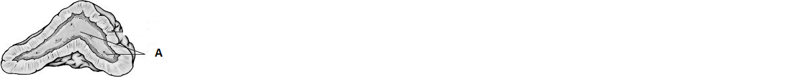

Explain why pheochromocytoma might cause these symptoms.

(5 marks)

__________________________________________________________________________________________________________________________________________________________________________________________________________________________________________________________________________________________________________________________________________________________________________________________________________________________________________________________________________________________________________________________________________________________________________________________________________________________________________________________________________________________________________

**3.** To maintain thyroid function and a normal basal metabolic rate (BMR), a series of events must take place involving the thyroid gland and its interaction with two other structures in the body. Describe the series of events involving the thyroid gland and these two other structures that would occur to prevent a healthy person’s BMR from dropping to below normal levels.

1. marks)

__________________________________________________________________________________________________________________________________________________________________________________________________________________________________________________________________________________________________________________________________________

_________________________________________________________________________________________________________________________________________________________________________________________________________________________________________________________________________________________________________________________________________________________________________________________________

4. Chose four(4) pituitary hormones, two from each lobe, and describe their effects and respective target cells or organs.

(8 mark)

_______________________________________________________________________________________________________________________________________________________________________________________________________________________________________________________________________________________________________________________________________________________________________________________________

_______________________________________________________________________________________________________________________________________________________________________________________________________________________________________________________________________________________________________________________________________________________________________________________________

1. Describe the action of steroid and amine (peptide) when they reach their Target cells.

(6marks)

_______________________________________________________________________________________________________________________________________________________________________________________________________________________________________________________________________________________________________________________________________________________________________________________________

1. **List two hormones that** can increase blood glucose levels. State the gland where each is made.

(4 marks)

__________________________________________________________________________________________________________________________________________________________________________________________________________________________________________________________________________________

1. Nesidioblastosis is a disease that causes the beta cells of the pancreas to become enlarged and over productive. This causes hypoglycemia. Explain why?

(3 marks)

__________________________________________________________________________________________________________________________________________________________________________________________________________________________________________________________________________________________________________________________________________

Use the graph below to answer the questions that follow. It show the changes in hormones during one ovarian cycle.

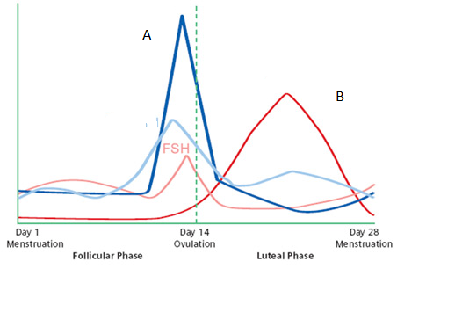

1. Which hormone is represented by the letter A? Give a reason for your choice.

(2 marks)

________________________________________________________________________________________________________________________________________________________________________________________________________________________________________________________________________________________________________________________

1. State the name, place of production and effect of hormone B.

(3 marks)

________________________________________________________________________________________________________________________________________________________________________________________________________________

1. Describe what is meant when a target cell has reached hormone saturation.

(3 marks)

________________________________________________________________________________________________________________________________________________________________________________________________________________________________________________________________________________________________________________________________________________________________________________________________________________________________________________________

9. Describe the Pineal glands response to darkness and the affect this has on the body.

(2 marks)

____________________________________________________________________________________________________________________________________________________________________________________________________________________________

THE END